**GM Diet Plan and Benefits**

If I count to how many times I have shook my head for a pizza, burger, soft drinks, chowmein, and all those mouth watering eatables being offered to me, I would get an answer- ZERO times!

What a lazy obese person would declare ‘IMPOSSIBLE’ other than getting a disease- free healthy life (mainly)? Or even a slim and healthy person outsmarting in front of everybody, but feeling low in energy on inside?

No more worries!

Here, we have gathered a real quick process to boost up your stamina and bring back your hidden energy in a matter of 7 days! Yes, heard that right.

I am going to present a mountain before you and ask you to climb. The catch is, I’m going to provide a HACK. It will take you to the top, like someone pulling you up. Keep in mind, “You must not give up”.

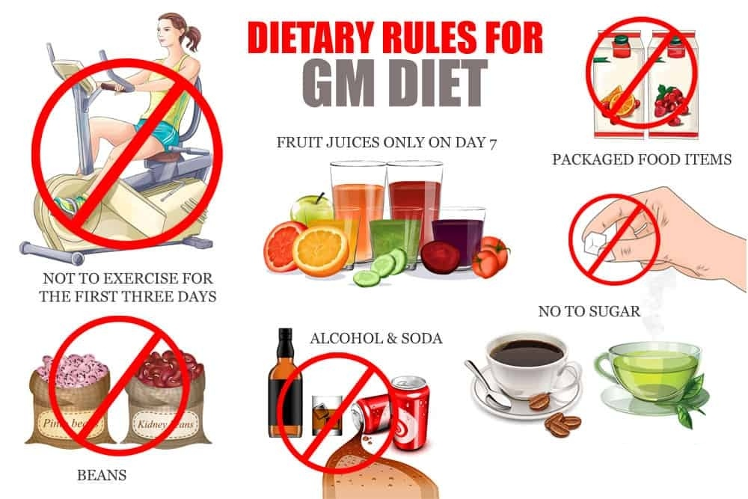

**General Motors Diet (GM Diet)**

General Motors Diet commonly known as GM diet is the mountain I was talking about. Consider it a building of 7 floors. Start climbing one floor each day and you are all set to enjoy the game.

General Motors gave rise to this thoughtful strategy of paying wages to their workers and offering some add-ons in the form of HEALTH i.e. a GM diet meal plan and eventual weight loss benefits.

**GM diet and how it works?**

GM diet meal plan is to be followed with full zeal. The GM diet menu consists of nourished food rich in fibre and low in carbs (carbohydrates or starch, main cause of expanding tummies), a basic amount of fats and proteins and a lot of water to take away body’s dullness.

**GM diet and weight loss**

People have witnessed a weight loss of 7 kgs (max depending upon body type) by following up with GM Diet meal plan and avoid intake of excess of calories available as aerated drinks, sweets and alcohol (pure calorie and synonym of degradation).

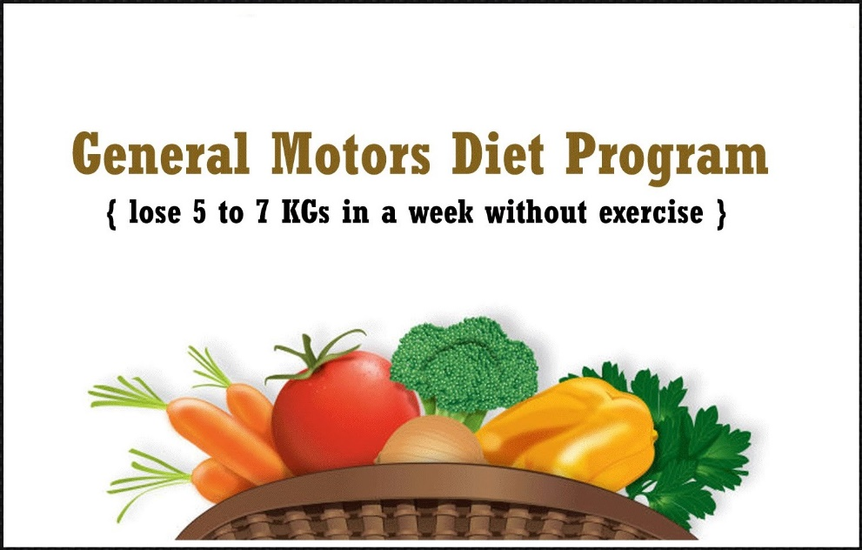

**GM diet chart**

ESSENTIALS:

* Drink atleast 7 to 8 glasses of water everyday.
* Zero consumption of junk food and carbonated drinks.

GM Diet menu:

* Hack to cross 1st building block (**Crave for luscious fruits**)
* Eat as many fruits as you can. Watery fruits such as Melon, watermelon, apple, orange, papaya are preferred. Avoid banana.
* Consume water before and after fruits in a gap of half an hour.
* 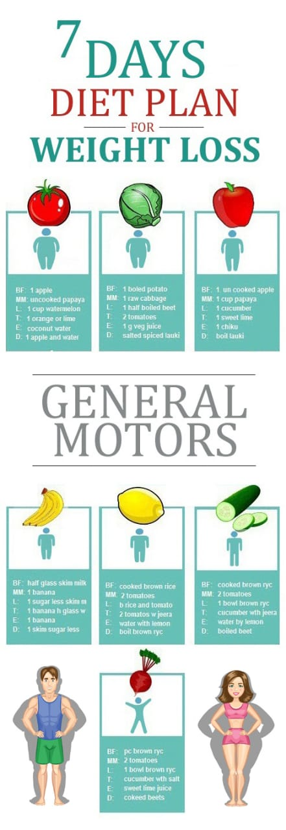Coconut water adds to the nutrition.
* Hack to cross 2nd building block (**Look out for green vegetables**)
* You can have some boiled potatoes for breakfast.
* Grab over some whole tomatoes, half boiled beetroot, cucumber, broccoli, spinach, lettuce and other vegetables.
* You can have boiled vegetable soup or tomato soup without adding sweeteners.
* Hack to cross 3rd building block (**A mix of fruits and vegetables today**)
* Prepare a meal including half boiled veges and top with colourful fruits.
* Go for GM Diet meal soups for a change.
* Hack to cross 4th building block (**Banana combined with milk**)
* 2 bananas with a glassful of milk in each meal.
* You can have GM Diet soup for a change. Again, no sweetener to be added!
* Hack to cross 5th building block (**Citrus rich diet and rice**)
* Take tomatoes or apple with a bowl of rice and boiled veges.
* GM Diet meal soup is always happy to accompany!
* Try variety in fruits and benefit your body at max.
* Hack to cross 6th building block (**Chicken and salad**)
* Arrange boiled veges with brown rice.
* Chicken breast, fish, lentils are preferred.
* Hack to complete the series of building blocks (**Juices)**
* Blend fruits and fill your stomach with liquids (help flushing toxins easily).

**Not to forget about General Motors meal plan**

* Don’t eat GM Diet foods exceeding your hunger limit.
* Eat GM Diet menu in front of a mirror. it will encourage you.
* Avoid drinking too much water after 8pm.
* Don’t follow the GM Diet foods or GM Diet chart too strictly. Take your own peaceful time.